(Approx. 1032 words)

Hoopla – Fran & Ollie
By Phil Sorrentino, Newsletter Contributor, Sarasota Technology Users Group
www.thestug.org
philsorr (at) yahoo.com
No, that was Kookla, Fran & Ollie. (Well, that probably gives away the fact that I grew up in the 1950s near New York City.) But the important point here is that Hoopla is a (new) free Movie Streaming service offered by many county library systems. In Hillsborough County, it is being provided by the Hillsborough County Public Library Cooperative, HCPLC. Many of us are probably familiar with borrowing ebooks and audible books from the library using Overdrive or Libby on our mobile devices (phones and tablets). However, Hoopla provides a little bit more. Hoopla is a website and an App (for mobile devices) that allows you to borrow movies, TV shows, and music selections as well as ebooks and audible books. If the idea of borrowing books and movies using your phone or tablet is new, try some of the YouTube videos on the subject. Just Google “Hoopla,” scroll down to the Video section, and choose the one that sounds like it may be helpful. While you are there, you may as well watch all of them to give you the best introduction to the idea of going to the library without ever leaving your house.
The website is “hoopladigital.com,” and an app is available for Windows, Mac, iOS, and Android. The icon for the mobile app looks like this:
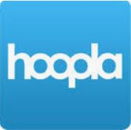
Hoopla is a cloud-based digital media platform that enables users to instantly borrow entertainment media and educational material via the website or the Hoopla mobile app on a tablet or smartphone. Library cardholders of libraries that support Hoopla have unlimited access to the library’s collection of digital media. Hoopla is a streaming service, and when it comes to streaming services, they are all vying for your time, and most of them are also after your money, but as said above, Hoopla is free. Hoopla is more like a library than a “blockbuster” store. You can think of Hoopla as a free pay-per-view video streaming service, like Netflix or Hulu, where your public library has picked up the monthly membership fee. All you need is a library card, and you can get an account. (If you have multiple library cards, say from a library in Florida and a card from a library up north, you can get an account for each of those libraries and possibly double your access to entertainment and information media.) Once you have an account, you can borrow movies, TV shows, music CDs, ebooks, audible books, and comics (cartoons). When you borrow these, like borrowing items from any library, there are some limits. All libraries may not be the same as HCPLC. HCPLC allows you to borrow 20 movies per month. When you borrow a movie, you can have it for three days. If you do not “early return” the movie, it will be automatically returned at the end of the three-day period. Because of this automatic return at the end of the borrowing period, there are never any late fines. HCPLC has a pretty substantial media inventory. Over 12 thousand movie titles, over 2 thousand TV shows, over 45 thousand CD titles, 180 thousand ebooks, 51 thousand audible book titles, and 13 thousand comics (cartoons) are listed in the inventory.
For anyone that likes to watch movies on their big-screen TV (as always with displays, size counts, and the bigger, the better), once you borrow the movie, Hoopla provides the ability to Cast your movie to a cast enabled TV. You can Cast the movie from your smartphone or tablet to a TV with the cast receiving capability built into the TV. (Or you can use a Google Chromecast device to give a regular TV the cast receiving capability. By the way, the newest Chromecast device includes a controller that makes controlling the device a bit easier.)
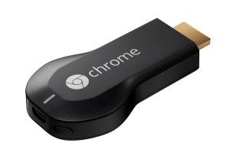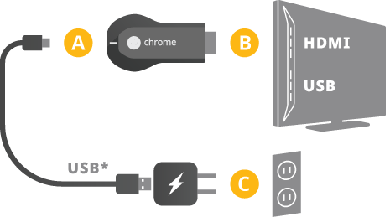
Chromecast Device Chromecast Installation
For a casting discussion (or review), refer to the article “Cast your Smartphone” in the June 2018 Journal.
So, after you find the movie you would like to borrow and select the movie, look for the cast icon up in the upper right part of the screen. The cast icon looks like this:
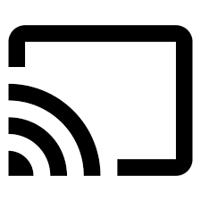
Touch the Cast icon and then look for the cast device name (typically your TV name) on your tablet or smartphone. (If there are more than one cast-enabled devices nearby, you will see a list of those devices.) Find the cast-enabled device and choose it. This sets up a connection between the library movie server and your TV (or Chromecast device attached to a TV) via your home wi-fi. Now you can control the movie from your smartphone or tablet or the TV controller. You can start and stop the movie and jump to a specific point within the movie. Once you have watched the movie, you can “early return” it to the library if there is still some time left, or you can keep it till the end of its borrowing period and show it again. It goes back into the inventory whenever you return the movie so other library members can borrow it.

Note that Hoopla has a Search feature. It is the “Magnifying glass” icon at the bottom of the Hoopla page.
Search Icon
You can “Search by title, artist or series,” as it says in the Search bar. When your search is successful, each item is shown as a thumbnail along with the type of media. Make sure you check the media type, so you don’t download an ebook when you are looking for a movie. If you look for movies, you can use another App to get some information about the movie. IMDB (Internet Movie Data Base) can give you a quick synopsis of the movie, along with the cast, a trailer, and even a rating (so you don’t waste your time with a dud). You can use both IMDB and Hoopla together to decide on a movie and then download and cast your borrowed movie to your big screen TV; imagine that all at no cost (given that you already have a tablet and a Chromecast device and a TV).

